TAKING NOTES ONLINE & NOTE-TAKING TOOLS

Should I take notes while listening to / viewing an online lecture?

In short, yes. and often.

Although all your course content is online, and is all recorded digitally, it's still important to take notes:
- Taking notes helps you stay engaged
- Taking notes helps you concentrate, and
- Taking notes helps you retain information (useful for exams and assessments)

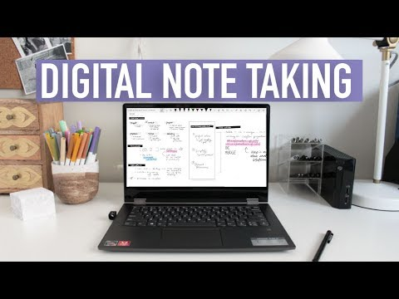
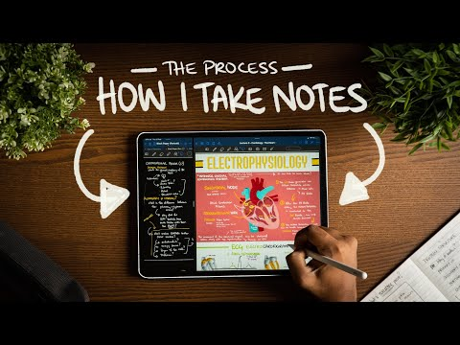
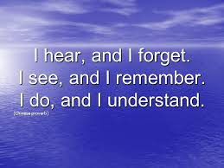

Really, you should:
- Take notes before, during and after each lecture.
- Take notes while doing any preparatory reading,
- Take notes while listening/viewing. And,
- Regularly review lecture notes after lectures.

Here are some of the best free Online note-taking tools:

- Evernote: (take notes, clip web pages, and record audio)
- Microsoft Onenote: (organise thoughts, to-do lists, and projects– available to you via your Office 365)
- Google Keep: (card-based notes for ideas, lists, images, draft documents –colour-coded & synchronised)
- Bear: (quick notes to in-depth essays, advanced markup options & a focus mode helps you concentrate)
- Atom: (collaborate & edit code in real time)
- Simplenote: (organise & synchronise your notes, collaborate with others)
- Dropbox Paper: (create, edit & prioritise documents, monitor team activity, post & reply to comments)
- Scratchgraph: (freeform – capture, structure & connect ideas, collaborate & share with others)
- Other apps: Colornote; Milanote; Zoho
- Using pen and paper is still useful. No access to the internet means you are not so easily distracted. You can also allow take notes in any style you prefer, whether that's creating columns, mind maps , etc.
- Use audio to take your notes

Finally, to help you maintain your focus and take notes you can work with,
- Find a space where you are comfortable to listen/review the lecture
- Set aside a good chunk of time (1 hr) to study, free of distractions
- Try to listen/review the lecture when you're most alert (such as in the morning, or early evening)
- When you find something that you need or adds to what you already know about a topic, document it (remember to note the source)
- Rewrite material – e.g. write notes in your own words during a presentation or for exam preparation, or convert text into diagrams, use flashcards
- Apply concepts, such as answering questions (you identified /noted while doing your preparatory reading), and solve problems

Reference.
Caitlin’s Corner. (2018, August 24). Digital note taking tips: One note + handwriting [Video file]. retrieved from https://www.youtube.com/watch?v=MBwU7labwKE

Online Study Australia (2020). Retrieved from ahttps://onlinestudyaustralia.com/courses/how-succeed-tips/

Singleton, E. (2016). Numeracy Workshop Numeracy. I hear, and I forget. I see, and I remember. I do, and I understand. (Chinese proverb) [Image]. Retrieved from https://slideplayer.com/slide/6185124/

Suresh, S. (2020, February 26). How I take notes with my iPad Pro in lectures (Notability & GoodNotes) + free template [Video file]. Retrieved from https://www.youtube.com/watch?v=n0ql-yeY9u0

Techradar Pro. (2019). Best note-taking apps of 2020: take notes on the go with a mobile app. Retrieved from https://www.techradar.com/au/best/best-note-taking-app

